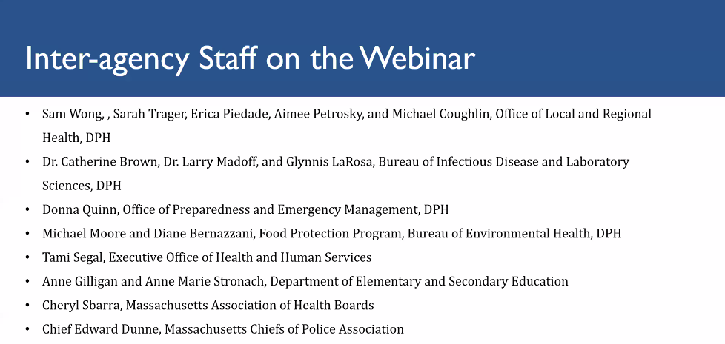
Paxlovid COVID-19 Therapeutic - Tami Segal, EHS
Free Telehealth Treatment with Paxlovid: MA launched Free Telehealth service to provide COVID-19 antiviral treatment called Paxlovid. Paxlovid is a COVID-19 treatment pill taken orally that can reduce the risk for severe symptoms and hospitalizations by nearly 90%. All COVID-19 positive individuals over 18 years old in the commonwealth are eligible for this program, no insurance required. Telehealth programs are a quick, easy and free way for individuals to see if Paxlovid is an appropriate treatment for them. If an individual is eligible, clinician will send prescription to a nearby pharmacy, or if necessary arrange for free overnight delivery to a patient's home.
*Several symptoms such as chest pains/breathing issues would disqualify patient from telehealth and instead they will be directed to seek a higher level of in-person care.

Program can be accessed at www.mass.gov/COVIDtelehealth. Contact Color Support Team at 844-352-6567 or treatments@color.com for help with telehealth service.

Q&A Session: Paxlovid
Q: What about people who are experiencing homelessness? Must people list a physical address at which they reside?
A: Individuals need to list an address for legal reasons, but the address itself is flexible. Homeless individuals can put the location of a shelter.

Shared Kitchens - Michael Moore
Shared kitchens refer to a shared food preparation facility in the community with kitchen space and access to professional equipment. The following are codes that are frequently overlooked by health departments but may help you better regulate shared kitchens in your area. These provide a way of putting controls on shared kitchens that may be out of hand.

105 CMR 590.010 (H)
- - Leased Commercial Kitchens are food preparations facilities that provide space and access to professional equipment on a lease or rental basis.
Required approvals:
- - The lessor of a Leased Commercial Kitchen shall not rent or share the kitchen unless it has been approved to do so and has obtained a valid permit from the board of health. Each shared kitchen is subject to inspection and enforcement as a retail food establishment.
- - Each lessee of a Leased Commercial Kitchen must obtain
-A retail permit from a BoH, and/or
-A wholesale food permit from DPH

105 CMR 590.010 (J) Innovative Operations
- - Description. Innovative operations are a non-traditional food establishments that are not listed in the 105 CMR 590.008 (f)
- Innovative Operation Approvals
  - Unless prohibited by 105 CMR 590.000, a board of health may approve a permit for an innovative operation, provided that it is in harmony with the general purpose and intent of 105 CMR 590.000
  - Each innovative operation permit shall be subject to general or specific provision set forth by the board of health, which may impose conditions, safeguards and limitations on time or use

Note: Health departments are also not exempt from requiring a certified food manager to further oversee the situation. Another tool that people don’t use enough is in 14b (105 CMR 590.014 (B)), which says the board of health has the authority to suspend the operation of a facility OR one or more particular operations of the facility. Use the existing code to get a handle on unusual occurrences.

Additional Resources:
- Conference for Food Protection www.foodprotect.org
  - 2011 Temporary Food Establishments
- Association for Food and Drug Officials https://www.afdo.org/about/
  - 2012 Cottage Foods
  - 2017 Incubator Kitchens
  - 2021 Wild Mushrooms
- DPH/BEH/FPP - Retail Food www.mass.gov/lists/retail-food
  - 2018 Merged Food Code
  - DPH Guidance Documents
    - Mobile Food Units
    - Temporary Food (including farmers markets)
    - Residential and Cottage Foods
- Residential Kitchen Guidance: https://www.mass.gov/lists/retail-food#residential-kitchen-guidance-
- On-farm Cottage Guidance: https://www.mass.gov/doc/guidance-for-farms-and-agricultural-businesses-on-cottage-food-and-other-food-sales-march-8-2022-0/download

Monkeypox Virus - Dr. Catherine M. Brown
What is monkeypox? Virus related to smallpox. Endemic to parts of Central & Western Africa. Rodents are likely a reservoir. Recently, there has been an increase in cases in non-endemic countries.
Signs & Symptoms: In typical presentation of monkeypox, the incubation period is 3-15 days. Symptoms start with fever/chills, headache, core throat or cough. Rash begins within 5 days of symptoms onset. Other typical symptoms include:
- Rash more often on face
- Lesions may be on palms or soles
- Lesions often painful
- Rash evolution: often oral lesions first
- Can resemble more common diseases – syphilis, herpes, chicken pox
Recent cases have more atypical presentations, including:
- fewer lesions
- Unusual distribution - initial lesions often in genital/perianal area
- Prodrome often lacking, or may occur after onset of rash
- Generally mild illness not requiring hospitalization (only one global death as of June 15)

Transmission: There is no evidence at this time that people transmit before symptom onset, but emphasis this is an EMERGING situation that may change.
Modes of Transmission:
- Direct contact with lesions or with fomites contaminated with material
- Large respiratory droplets during face-to-face contact *at this point, no evidence of transmission from aerosols
- Contact with infected animals
Causal contact not known to be a risk factor. Household contacts in Africa have been infected.
Transmission on flights has not been documented. Outside Africa, only 1 healthcare worker case has been documented. Infectious period ends once all lesions that have scabbed and scabs fall off.

Unknowns: Virus detected in semen – unknown how that contributes to spread. Also, are there asymptomatic cases and how do they impact transmission?
Testing: PCR testing available at SPHL. Confirmation of monkeypox virus occurs through CDC> Currently there is a manual process for testing: providers call DPH to triage the need for testing. An automated process will be made available soon, which will increase the number of specimens the SPHL can test per day. Should be available mid-July.
Testing Samples: Fluid or crusts from lesions are best sample. Throat swabs are being evaluated as possible sample type. Serum to test for antibodies requested but not tested at this time. Results of testing within 24-48 hours. Instructions for specimen collection: https://www.mass.gov/monkeypox

Close contacts
Use CDC exposure risks resource on website: https://www.cdc.gov/poxvirus/monkeypox/clinicians/monitoring.html
High Risk
- Prolonged contact
- Handling bedsheets of infected person
Intermediate Exposure
- 6 feet for 3 hours
- Clothing had contact with patient
Low/ Uncertain Exposure
- Contact with most/all PPE
- 6 feet of patient for less than 3 hours

Prevention:
Patients must isolate pending results. 21 day symptom monitoring period. If symptoms develop, isolate and contact public health. Location of isolation following confirmation varies: hospital, home if living alone, home with roommates if positive case can cover lesions, wear a mask, and stay in room. Isolation lasts 2-4 weeks (all lesions must have scabbed over and scabs fallen off).
at the moment, high risk contacts should not travel, but this is being reevaluated. High risk contacts are offered post-exposure vaccine with JYNNEOS. Ideally start within 4 days after exposure, up to 14 days.

Vaccine for Pre-Exposure:
ACAM 2000
- Smallpox vaccine
- Lots of stockpiled supply
JYNNEOS
- Smallpox and monkeypox prevention
- 2 doses 28 days apart
- Recommended for high risk lab workers and certain healthcare workers
- Limited supply but production in process

Therapeutics: Tecovirimat (TPOXX) is an FDA approved treatment for smallpox only, but CDC allowing expanded access with complex monitoring and protocol. Considered for a patient with severe disease or patient at risk for severe disease, such as breastfeeding women or pediatric populations.
Education & Resources:
Multiple sources of educational materials designed to inform but not stigmatize. Reference https://www.cdc.gov/poxvirus/monkeypox/index.html

Q&A Session: Monkeypox
Q: Are we still sequencing the same number of COVID samples and is our sequencing designed to be representative surveillance of the spread of variants and possible emergence of new ones in MA?
A: Sequencing is still happening on MA samples at the BROAD, the SPHl, and several academic institutions. In addition, CDC has funded a national program which is designed to provide representative surveillance information nationally. The testing happening in MA is on top of that and appears to be more than adequate to track emergence of new variants.
Q: Can we re-purpose the mechanisms in labs, healthcare settings, local public health, and testing to cover ALL respiratory diseases, instead of progressively dismantling these as public and media preoccupation (but not necessarily objective health risk) fades?
A: This is definitely part of the national planning which is to transition slowly from COVID-focused surveillance to respiratory illness surveillance. As you know there have been funding opportunities to support workforce capacity development, funding available for national data modernization initiatives and ongoing conversations about how to ensure public health is better supported and prepared moving forward.

