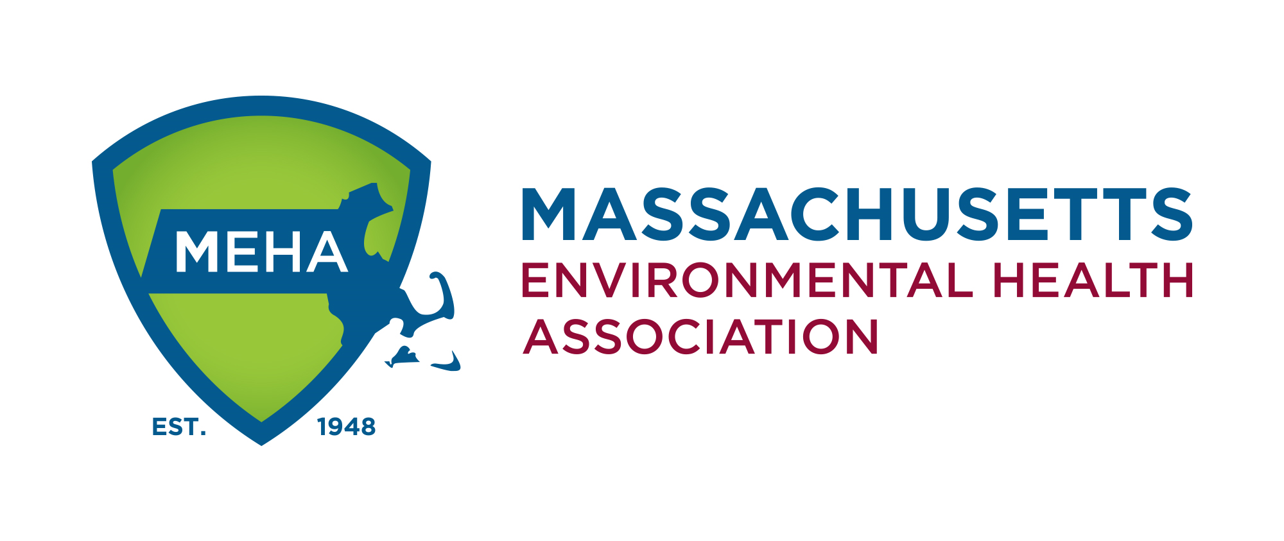

Massachusetts Environmental Health Association

AMBASSADOR
PROGRAM

Program Guide

MASSACHUSETTS ENVIRONMENTAL HEALTH ASSOCIATION AMBASSADOR PROGRAM
Thank you for your interest in assisting MEHA spread the work on the exciting career of Environmental – Public Health. The mission of this outreach program is to:
- Have MEHA Ambassadors present to selected groups on what a career in Environmental – Public Health is all about
- Target groups are High School Students, Community College Programs, Colleges and University Programs, school career offices and career fairs.
To achieve this outreach, we are recommending that Ambassadors reach out to:
- Your Alma Mater: Your high school, college, or university program
- Any schools including high schools and other educational institutions in the community in which you live or work
- School career offices and any advertised and approved career day events
To avoid overlap and duplicating presentation efforts, you are requested to contact MEHA’s Ambassador Program Coordinator at admin@maeha.org prior to your outreach. We will track the location where you are considering your presentation to ensure that another Ambassadors have not recently occurred or is scheduled to occur at this location.
Why is our Association starting this program?
- The practice of Environmental Health is an exciting and noble career path to take. We want to get the word out!
- Many seeking such a career may not know about it and how to enter the profession.
- Locally and nationally, there is a significant shortage of people entering the practice and significant numbers leaving due to retirement or pursuit of different career paths.
- Your outreach can be instrumental is addressing this concern and being new and energetic individuals to our profession.
To assist you in this endeavor, MEHA will provide expenses (tolls and gas mileage) to any institution you travel to in the NEHA region 9 area. Any locations beyond Region 9 (https://www.neha.org/about-neha/neha-regional-vp) will require reimbursement approval from the MEHA – Ambassador Program Coordinator and the MEHA Board.
Attach to this packet is a form needed to 1) inform MEHA of the institutions at which you plan to present, and 2) the request for reimbursement for allowed cost related to the presentation.
In addition, you will find links to the Power Point presentations we have put together for this project. You will note we have made a short version for a 45-minute presentation plus 15 minutes Q&A (total 1 Hr.) a longer version for a 75-minute presentation, plus 15 minutes Q&A (total 1 ½ Hr.), and a presentation that has additional slides on Food Safety which will take 90 minutes, with 15 minutes of Q&A (1:45 total).
These presentations are suggested guides. You can adjust them to meet your needs, presentation style, or audience.
Lastly, we have listed some links that will provide you with tips on successful PowerPoint presentation should you feel rusty on such presentations.
Again, thank you for your participation and efforts in the MEHA – Ambassador Program.

– MEHA Ambassador Program Committee
LINKS TO PRESENTATIONS AND GUIDES
- Got Presentation Rust? 3 Steps to shake it off
https://edtate.com/got-presentation-rust-3-steps-to-shake-off-presentation-rusty-habits/
- 7 Tips for improving presentation skills: https://slidehunter.com/7-tips-improving-presentation-skills/
- The 5 P’s of Presentation:
http://ffolliet.com/2018/12/28/five-ps-of-presentation/

MEHA – AMBASSADOR PROGRAM: NOTIFICATION – REIMBURSEMENT FORM

NAME: _______________________________ EMAIL: _______________________

ADDRESS: ___________________________
___________________________
___________________________
____________________________
PHONE: _____________________________
WORK LOCATION: ___________________________________________________

AMBASSADOR PRESENTATION REQUESTED FOR THE FOLLOWING:

- ________________________________________ DATE: ________________
- ________________________________________ DATE: ________________
- ________________________________________ DATE: ________________
- ________________________________________ DATE: ________________
- ________________________________________ DATE: ________________
- ________________________________________ DATE: ________________

PLEASE EMAIL COMPLETED FORMS TO MEHA’S AMBASSADOR PROGRAM COORDINATOR AT ADMIN@MAEHA.ORG FOR REVIEW AND SCHEDULING APPROVAL TO ELIMINATE POTENTIAL OVERLAP.

