Announcements
COVID-19 Vaccine Update – Laurie Courtney, DPH
- For primary and booster vaccinations for all populations, an mRNA vaccine series is preferred over the Janssen vaccine. However, offering the Janssen vaccine is preferable to not providing any COVID-19 vaccine.
- Primary series in the general population (for people who are NOT immunocompromised)
  - Feb 22nd CDC updated its Clinical Considerations and added considerations for an 8-week interval between the first and second doses of a primary mRNA vaccine schedule (stronger immune response and further minimization of the already rare risk of adverse events).
    - The updated guidance is specific to the mRNA vaccines and is only for some patients that are not yet vaccinated.
      - People ages 12-64 years who are not moderately or severely immunocompromised
      - Particularly males ages 12-39 years
- Important to note:
  - Patients who meet the criteria and have already received their primary mRNA series at the 3-week (Pfizer) or 4-week (Moderna) interval remain well-protected, especially if they received a booster dose, and do NOT need to repeat any doses.
  - The extended interval is NOT recommended for all people ages 12-64 years, and there are situations where providers should continue to recommend the 3-week and 4-week intervals between primary doses (ex. concern about high levels of community transmission and among people who are moderately or severely immunocompromised).
  - The extended interval is NOT recommended for anyone 65 and older.
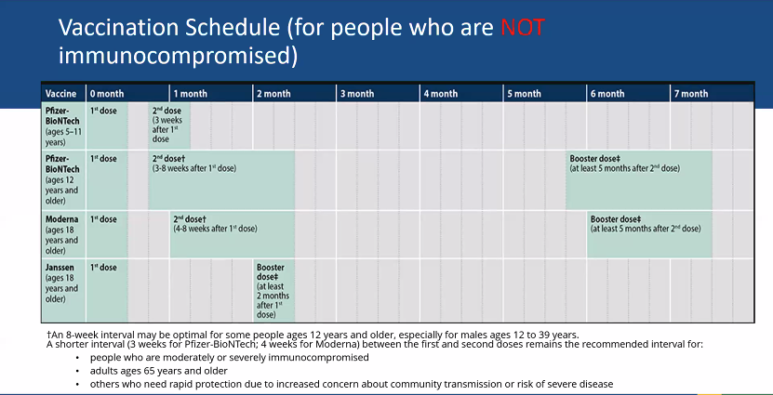

- Vaccination schedule for people who are moderately/severely immunocompromised – February 11th updates to the Clinical Considerations
  - Clarification of recommendation to receive a 3-dose mRNA vaccine primary series followed by a booster dose for a total of 4 doses.
  - New guidance to shorten interval between completion of mRNA vaccine primary series and the booster dose to at least 3 months (instead of 5 months).
  - New guidance for those that received the Janssen primary series to receive an additional dose and a booster dose, for a total of 3 doses to be up to date.
  - Appendix B – Guidance for People who are Moderately or Severely Immunocompromised and Vaccinated with Janssen COVID-19 vaccine.

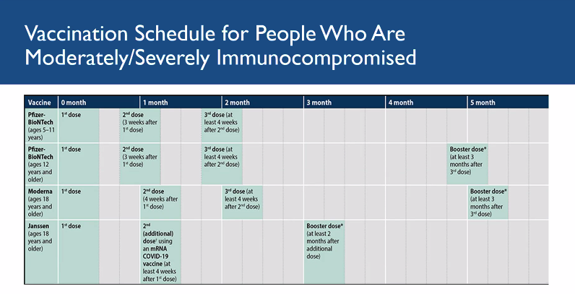

- February 24th COCA Call – Updated guidance for clinicians on COVID-19 vaccines
  - CDC experts presented a summary of updated recommendations on COVID-19 vaccines for people who are moderately or severely immunocompromised, simplified recommendations for vaccination following receipt of passive antibody therapy, and summarized recommendations for COVID-19 vaccination by age group
  - Slides and recording: https://emergency.cdc.gov/coca/calls/2022/callinfo_022422.asp

Updated Advisory Regarding Face Coverings – Jana Ferguson, DPH
- DPH updated its advisory on face coverings and advises that a fully vaccinated person should wear a mask or face covering when indoors (not in your own home) if you have a weakened immune system, or if you are at increased risk for disease because of age, underlying medical condition, or if someone in the household has a weekend immune system, is at increased risk for severe disease, or is unvaccinated.
- Individuals who are not fully vaccinated should continue to wear a face covering or mask to help prevent spreading COVID-19 to others.
- Individuals who are considered close contacts or have tested positive must follow the isolation and quarantine guidance, that includes wearing a mask in public for 5 more days after they leave isolation or quarantine on day 5, regardless of vaccination status.
- All people in MA are required to continue wearing face coverings in certain settings (ex. transportation and health care facilities).

K-12 COVID Response Update
- DESE shared the following announcement with districts and schools.
  - CDC announced, that effective Feb. 25th, 2022, it is no longer requiring that masks be worn on school buses or vans for K-12 students and children in childcare programs. Schools and districts may decide whether to lift or maintain local mask requirements on buses or vans.
    - As always, any individual who wishes to continue to mask should be supported in that choice.
    - More information on updated CDC guidance available here: https://www.cdc.gov/coronavirus/2019-ncov/travelers/face-masks-public-transportation.html
- Important links on DESE website & Rapid Response number
  - COVID-19 Testing Program: https://www.doe.mass.edu/covid19/testing/
  - Protocols for responding to COVID-19 scenarios: https://www.doe.mass.edu/covid19/on-desktop.html
  - NEW – FAQ compilation document on protocols and other reopening FAQs: https://www.doe.mass.edu/covid19/faq/
  - Rapid Response line 781-338-3500.

Q&A Session
Dr. Katie Brown – DPH
Q: Can you provide an update on Omicron BA.2?
A: BA.2 represents approximately 10% of current cases in the northeast U.S. and has not, so far, been responsible for significant surges anywhere in the U.S. Information about its infectious and severity remain mixed and inconclusive.
There is a piece of misinformation out there about PCR tests and BA.2. It has been called (inappropriately) “stealth” Omicron because it does not have the S-gene target failure pattern of positivity on the Taqpath PCR. This S-gene target failure pattern of positivity was used as a proxy to presume a sample was the original Omicron variant before a sample could be sequenced. That does NOT mean that PCR tests do not detect it.
BA.1.1, another sub lineage of Omicron which has become the most common variant present (70-80% of all cases), has turned out to pose a new problem. Evusheld, a monoclonal antibody given as a pre-exposure prophylactic to immunocompromised people who are unlikely to respond to the vaccine, has been shown to be less effective against BA.1.1. In fact, the FDA has just recommended doubling the dose of Evusheld to increase its efficacy.
Q: Are the oral tablets available outpatient and inpatient?
A: Yes. Most antiviral treatments are not limited to hospitalized patients. The most current information for providers is available here: https://www.mass.gov/info-details/information-for-providers-about-therapeutic-treatments-for-covid-19 and this webpage also includes information on where therapeutics are available, including some Walgreens and CVS stores (for people with prescriptions from their providers).

Q: Now that case numbers have come down, is it suggested that we follow up with all cases again? I know when the Omicron surge occurred in the first week of January, we were told to focus on priority settings.
A: It is reasonable to consider follow-up with more cases when case numbers are lower and if you have the capacity, but there is not a requirement to do so. Case investigation can still yield important information and it gives you an opportunity to answer any questions people have. What surveillance will look like for COVID moving forward is still an open question. It may be that we will treat COVID the way we do flu and never follow-up on people with positive test. Or, we might end up using more of a sentinel surveillance system where only some portion of people get followed up on. In the meantime, I will continue to encourage you all to utilize your public health expertise to do what is appropriate to protect your communities.

Q: We got a notification from Massachusetts Department of Agriculture Resources on 2/22/22 about Highly Pathogenic Avian Influenza. Should we be pushing out information to the residents about what to do if they have an unexpected bird death/notice anything unusual with the wild birds in their yard?
A: Your Animal Inspector is your municipality’s link to MDAR, and you should work with them to identify appropriate next steps. What would be useful in my opinion would be to disseminate information to poultry owners in your town about what to look for in their poultry and how to report it if they have sick or dying birds. MDAR has a very good handout: https://www.mass.gov/doc/biosecurity-for-your-backyard-flock-2022/download. Surveillance in wild birds is already happening and there is no general recommendation to report individual sick or dead wild birds (wild birds die for many different reasons). Mortality events involving large numbers of sick or dying birds should probably be reported, but not necessarily just for avian influenza.

Jana Ferguson – DPH
Q: Will there be any information on recreation camps coming out if any? Are there extra healthcare staff required at camps this year?
A: No guidance will be issued for camps this year specific to COVID-19. There is not a requirement to have additional healthcare staff at camps this year. It is not bad practice to have more than one health care supervisor, but regulations only require one.

Cheryl Sbarra – Massachusetts Association of Health Boards
Q: Will the state be providing updated guidance for this year’s Town Meetings?
A: Open Meeting Law has been extended. Remote meetings will be permitted through July 15th, 2022.

Q: Does extending Open Meeting Law mean towns must have remote participation options for town meetings?
A: I have to look at the way the law is written. My guess would be if they do not have virtual participation then they would be required to make sure that anyone who wants to attend, can attend in person.
DESE – Anne Gilligan & Anne Marie Stronach
Q: Can schools opt to require students to test negative (that completed 5 days of isolation following a positive test) on day 6 when they return to school?
A: No, schools cannot require testing to return to school.
Other Updates
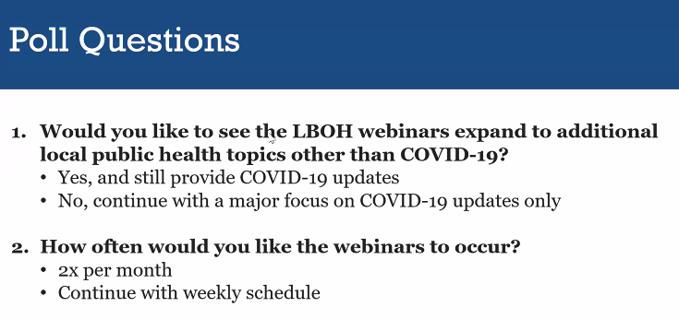
- Responses to the poll can be submitted to localregionalpublichealth@mass.gov.
- Submit questions for the next webinar to localregionalpublichealth@mass.gov by Thursday, March 3rd by 12 noon.

Questions answered from the Q&A chat
Rachel Lee
For 4th bullet: Continue to wear masks in public transport, not including school buses?

Erica Piedade
Answered live by Jana

Joanne Belanger
unless there is still a mask mandate in the community including for busses.

Jana Ferguson
Correct. If there is a local requirement, people would need to follow those requirements in that community.

Matthew Dow
Will there be any information on recreation camps coming out if any?

Erica Piedade
Being answered by Jana live.

Phoebe Walker
ah! so no more extra health care staff at camps this year?

Erica Piedade
Answered live

Jamie Terry
Responses are based upon a current lull in COVID -19 ... if things change I would have different answers. Thank you

Lois Luniewicz
how do you answer the poll?

Erica Piedade
It should have come on the screen and you can click on the answers. If it did no come up, please send your response to localregionalpublichealth@mass.gov

Webinar ended at 3:41pm.

